Thursday 2nd October, 2025.
Dear Parents / Carers,

Year 3, 4, 5, 6 Harvest Festival Assembly – Monday 13th October 2025, 9.45am.

We are writing to invite you to our Harvest Festival Assembly for Navigators, Wayfarers, Creators, Pathfinders, Venturers, Voyager, Crusaders and Discoverers classes on Monday 13th October 2025. The assembly will be at 9.45am.

As in previous years, we would welcome any food donations. All donations will go to the St Mary Magdalene Food Bank. Please do not feel that you must provide a donation.

Could you please indicate on the slip below if you intend to join us, to assist us with the seating arrangements. Please note that we will have to restrict parents / carers to a maximum of 2 seats per child, due to fire safety restrictions.

We look forward to seeing you and thank you for your support.

Yours sincerely,
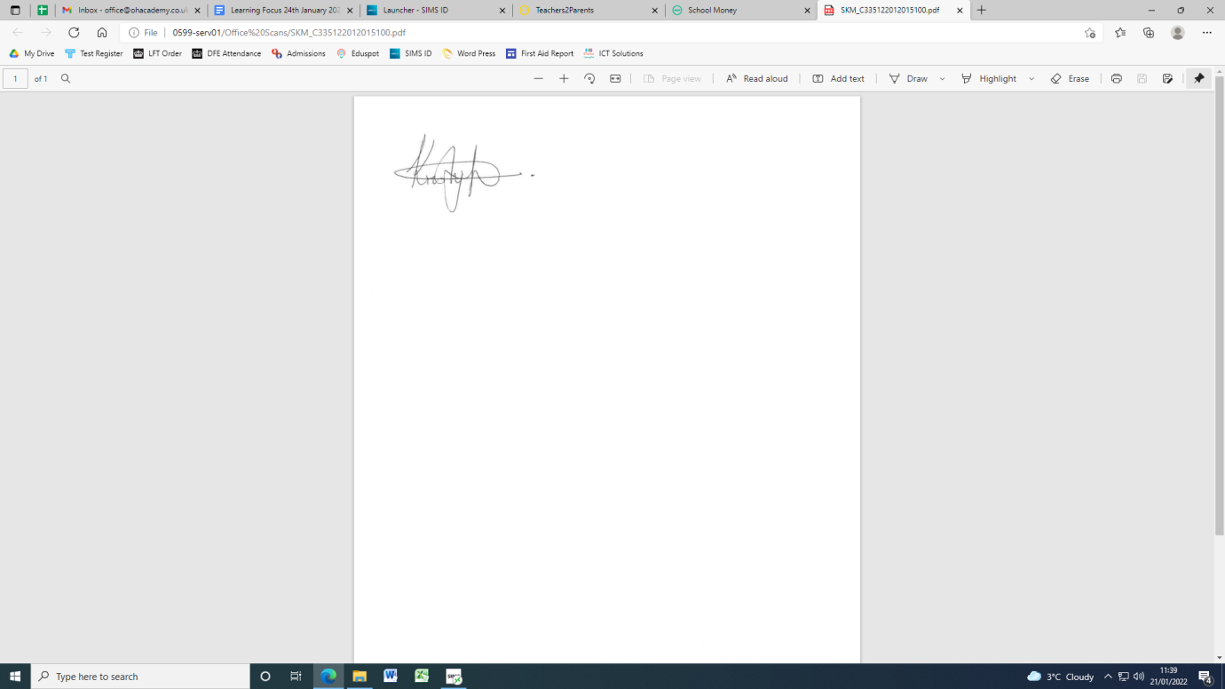

Mrs K. Redhead
Principal

&---------------------------------------------------------------------------------------------------------------------------------------

Year 3, 4, 5, 6 Harvest Festival Assembly – Monday 13th October 2025, 9.45am.

I am intending to join you for the Harvest Performance at 9.45am and require seats.
Seating is restricted to 2 seats per child.

Child’s Name: __________________________________________Class: ________________________

Parent / Carer Sign: __________________________________________Date: ____________________

