Key Vocabulary  Monarch- A leader of a country, e.g. a King or Queen.  Heir- The person next in line to throne who will take over when the current King or Queen dies.  Rebellion - the action or process of resisting authority, control, or convention.  Reign – The period of time that a monarch rules.  Church of England – Henry VIII created the Church of England so that he could divorce his first wife. The Catholic church did not permit divorce.  Reformation – The act of changing (reforming) something. In this case the reformation of the church to remove the Pope’s control.  Pope- The head of the Roman Catholic Church.  Divorce – The legal end of a marriage.  Execution – Being put to death.  Treason – To betray your country or monarch.  Beheading – A punishment which resulted in your head being chopped off with an axe.  Gallows- A wooden structure where people were hung by a piece of rope around their neck.  Stocks- A block of wood with two holes for your hands and a hole for your head to go in. Local people threw rubbish and rotten food at the people in the stocks. | Diagrams / Pictures  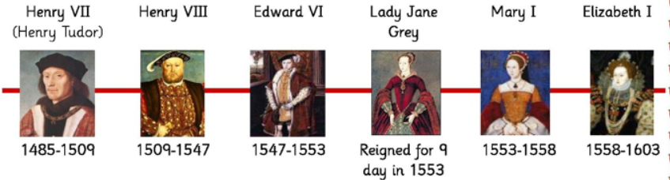  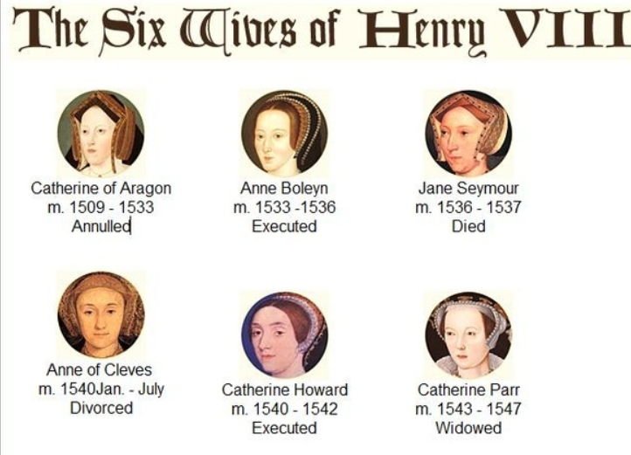
Key Facts:  1. There were six Tudor monarchs who ruled England from 1485 to 1603.  2. Tudor England had 2 of the strongest monarchs ever to sit on the English throne: Henry VIII & his daughter, Elizabeth I.  3. The Tudor rose was created when Henry VII brought an end to the Wars of the Roses. He joined the White Rose of York with the Red Rose of Lancaster to create the Tudor Rose.  4. Religion was very important in Tudor times. Everyone had to go to church. If you didn’t attend the same church as the monarch you might get arrested, thrown into the Tower of London, or even executed.  5. Henry VIII broke away from the Catholic church and created the Protestant Church of England so that he could divorce his first wife. He went on to have six wives, beheading two of them. | Important People:  Robert Kett  Kett's Rebellion was the most serious outbreak of unrest during the reign of Edward VI in 1549.  To think about:  What was the reason for these revolts in the 1540s and why did Robert Kett, a wealthy yeoman farmer and tanner, become the leader of this rebellion? 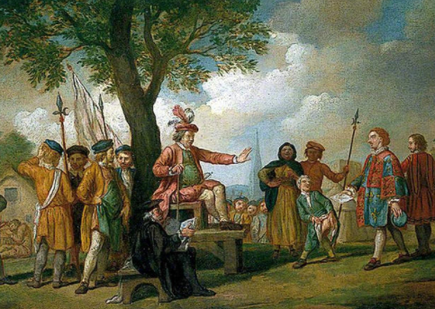  Enquiry:  - Sequence and structure complex subjects and themes.  - Start to suggest reasons for connections over time and across places and cultures.  - Comment on impact and legacy.  - Select, organise and use information from more than one source to construct an informed response and/or opinion.  - Explain the usefulness and reliability of different sources.  - Start to develop perspective and judgment by explaining how historical ‘facts’ are often interpreted to support opinions.  - Accurately summarise other people’s opinions about the past.

