Key Vocabulary  Afterlife - the place where Egyptians believed they would go after they died.  Akhet - The season of the year when the river Nile flooded. Very important in a desert!  Canopic Jars - Special jars that held the organs of the mummy including lungs, intestines, liver and stomach.  Dynasty - A period of rule when a series of Pharaohs all came from the same family.  Egyptologist - An archeologist who focuses on Ancient Egypt. Howard Carter discovered Tutankhamun’s tomb.  Hieroglyphics - A type of writing that uses a combination of pictures and symbols.  Mummification - The process of preserving a body after death in preparation for the afterlife.  Papyrus - A plant that grew on the banks of the Nile. It was used to make an early form of paper.  Pharaoh - The supreme ruler of Ancient Egypt.  Sarcophagus - A large stone box that held a mummy’s coffin. Often richly decorated for Pharaohs.  Pyramids - Structures located in Egypt. Mostly built as tombs for Pharaohs and other important people. | 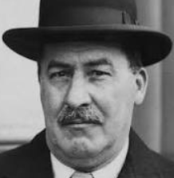  Important People  Howard Carter - 9th May 1874 - 2nd March 1939.  Became famous after discovering the intact tomb of Tutankhamun in November 1922.  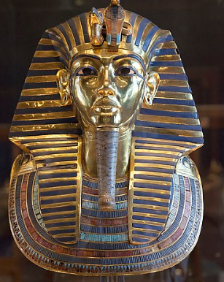  Tutankhamun - known as ‘The boy king’. Became Pharaoh at 8 or 9 years of age.  Historical enquiry and skills  - Describe how Egyptian artefacts and ruins tell us about their culture, and religious beliefs.  - Describe what Egyptian life was like for different groups of people.  - Describe how the Egyptian society has had an impact on modern society.  - Describe why people chose to settle in certain areas in ancient Egypt. Compare what was happening in the Egyptian civilisation with what was happening in Britain at the same time.  - Present what you know about the Egyptians using a variety of skills (e.g. Geography, English, Maths)
Key Facts  - Most pyramids were built as tombs for Pharaohs and their families. Over 130 pyramids have been discovered in Egypt so far.  - The afterlife was incredibly important to the Egyptians. They believed that by preserving a dead person’s body (which they did through the process of mummification) their soul would live on in the after-life forever.  - The Pyramid of Khufu at Giza is the largest Egyptian pyramid. This incredible structure weighs as much as 16 Empire State buildings!  - Both Egyptian men and women wore make-up. The eye-paint was usually green or black. As well as offering protection from the sun, the Egyptians believed make-up had magical healing powers, too.  - Unwrapped, the bandages of an Ancient Egyptian mummy could stretch for 1.6km.  - The Egyptian alphabet contained more than 700 hieroglyphs.  - Ancient Egyptians believed in more than 2,000 deities! They had gods for everything, from dangers to chores! Each had different responsibilities and needed to be worshipped so that life could be kept in balance.  - Cats were considered to be a sacred animal by the Ancient Egyptians. It’s thought that most families kept a cat as a pet, which they believed would bring the household good luck!  - The Ancient Egyptians invented lots of things we still use today, such as paper, pens, locks and keys and – believe it or not – toothpaste! | Diagrams / Pictures  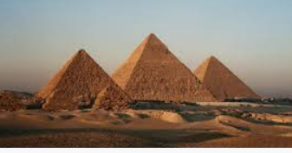  Ancient Egyptian Pyramids  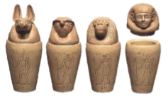  Canopic Jars  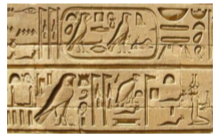  Hieroglyphics

