Key Vocabulary  Bakery - A place where bread or cakes are made and sold.  London - The capital city of England and the United Kingdom.  River Thames - River that runs through London. Many people got a boat on the River Thames to escape the fire.  Diary - A personal record of life’s events.  Eye-witness - A person who has seen something and can give a description of it.  Embers - Small pieces of glowing coal or wood in a dying fire.  Fire-hooks Giant hooks used to pull down houses.  Fire-break - When buildings are destroyed to make a gap so the fire can’t spread.  Flammable - When something burns easily.  St Paul’s Cathedral - A Christian building razed to the ground in the fire and rebuilt using designs by Sir Christopher Wren. | Important People  Thomas Farriner - An ember from one of Thomas’ bakery ovens ignited some nearby firewood. The fire quickly spread around the room and to nearby buildings.  Samuel Pepys - An administrator of the navy of England and Member of Parliament who is most famous for the diary he kept as a young man.  King Charles II - Charles II was the King of England in 1666. After the fire, he made a decree that houses must be built further apart and built from stone not timber.
Key Facts  - The Great Fire of London occurred in September 1666.  - The fire began in a Baker's in Pudding Lane.  - The fire lasted for 4 days and most of the city was destroyed. We know about the fire because people recorded the event in paintings, letters and diaries ( Samuel Pepys' diary is particularly famous).  - Before the fire, houses were often built very close together and were usually made from wood and straw.  - After the fire, houses were built further apart and were often built with brick.  - The fire brigade was formed due to the Great Fire of London.  - Sir Christopher Wren built a monument to remember the Great Fire of London. | Diagrams / Pictures  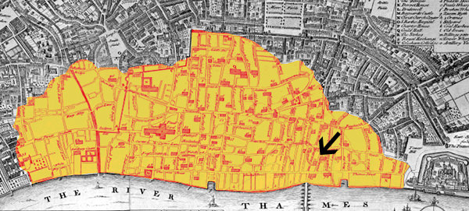  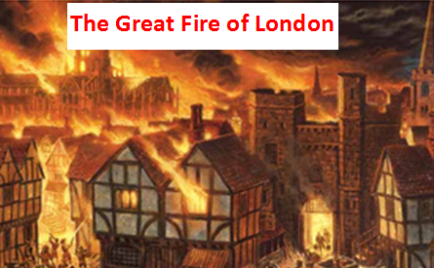  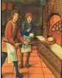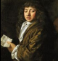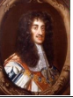  Thomas Farriner Samuel Pepys King Charles II  (in his bakery)

