Key Vocabulary | Important People  Toys in our Time
Wooden toys – toys made from wood  Paper toys – toys made from paper  Plastic toys – toys made from plastic  Metal toys – toys made from metal  20th century -  21st century  Artefact -  Past – already happened  Present – happening now  Modern – something that is new  Before – something that happens prior to an event  After – something that happens following an event  Generation – people born and living in the same time  Similarities – something similar/same  Differences – something that is not the same  Handmade – not made by a machine  Factory made – made in a factory  Chronology - from oldest to newest | Uemura Masayuki - Japanese designer .of the Nintendo console, or Nintendo Entertainment System (NES), 1983  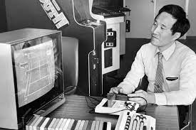
Key Facts
Toys existed for thousands of years- stones and strings were made into toys.
My grandparents' toys were usually made from wood and metal
Some toys have been used across the generations- scooters, teddy bears.
Old toys- often wooden, usually mechanical, moved by hand. New toys- often plastic, usually need batteries, made by machines y hand, handmade
Modern toys us Computers and consoles were invented in the 20th century e electricity to work
Victorian children played with toys- clockwork trains, rocking horses, tea sets, wooden boats, rag dolls filled with sawdust.
Pictures/diagrams


