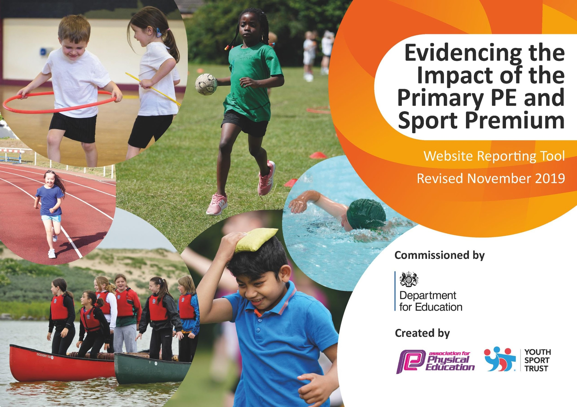
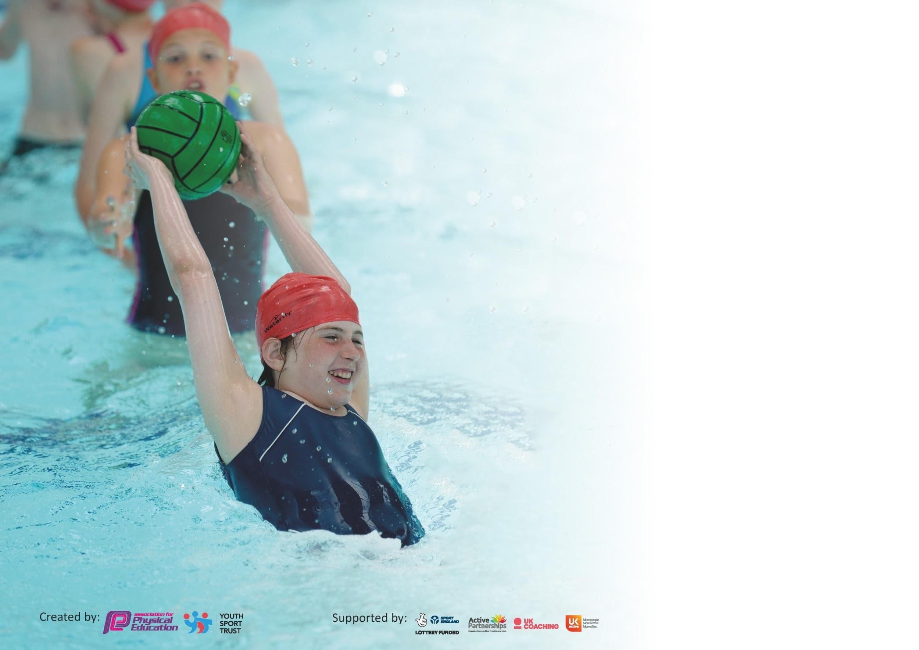

It is important that your grant is used effectively and based on school need. The Education Inspection Framework (Ofsted 2019 p64) makes clear there will be a focus on ‘whether leaders and those responsible for governors all understand their respective roles and perform these in a way that enhances the effectiveness of the school’.

Under the Quality of Education criteria (p41) inspectors consider the extent to which schools can articulate their curriculum (INTENT), construct their curriculum (IMPLEMENTATION) and demonstrate the outcomes which result (IMPACT).

To assist schools with common transferable language this template has been developed to utilise the same three headings which should make your plans easily transferable between working documents.

Schools must use the funding to make additional and sustainable improvements to the quality of Physical Education, School Sport and Physical Activity (PESSPA) they offer. This means that you should
use the Primary PE and Sport Premium to:

- Develop or add to the PESSPA activities that your school already offer
- Build capacity and capability within the school to ensure that improvements made now will benefit pupils joining the school in future years

Please visit gov.uk for the revised DfE guidance including the 5 key indicators across which schools should demonstrate an improvement. This document will help you to review your provision and to report your spend. DfE encourages schools to use this template as an effective way of meeting the reporting requirements of the Primary PE and Sport Premium.

We recommend you start by reflecting on the impact of current provision and reviewing the previous spend.

Schools are required to publish details of how they spend this funding as well as on the impact it has on pupils’ PE and sport participation and attainment by the end of the summer term or by 31st July 2021 at the latest.

We recommend regularly updating the table and publishing it on your website throughout the year. This evidences your ongoing self-evaluation of how you are using the funding to secure maximum, sustainable impact. Final copy must be posted on your website by the end of the academic year and no later than the 31st July 2020. To see an example of how to complete the table please click HERE.

Ormiston Herman Academy PE and Sport Grant 2022/23

Meeting national curriculum requirements for swimming and water safety.
What percentage of your current Year 6 cohort swim competently, confidently and proficiently over a distance of at least 25 metres?  N.B. Even though your pupils may swim in another year please report on their attainment on leaving  primary school at the end of the summer term 2020. | % 30
What percentage of your current Year 6 cohort use a range of strokes effectively [for example, front crawl, backstroke and breaststroke]? | % 30
What percentage of your current Year 6 cohort perform safe self-rescue in different water-based situations? | % 25
Schools can choose to use the Primary PE and Sport Premium to provide additional provision for swimming but this must be for activity over and above the national curriculum requirements. Have you used it in this way? | No

Academic Year: 2022/23 | Total fund allocated: £18,740 | Date Updated: July2022
Key indicator 1: The engagement of all pupils in regular physical activity – Chief Medical Officer guidelines recommend that primary school pupils undertake at least 30 minutes of physical activity a day in school |  |  |  | Percentage of total allocation:
 |  |  |  | %
Intent | Implementation |  | Impact
Ormiston Herman Academy we recognise the contribution of PE and Sport to the health and well-being of our pupils.We aim to provide a high-quality physical education curriculum that inspires all pupils to succeed in sports and other physically-demanding activities. We are committed to provide opportunities for pupils to become physically confident in a way which supports their health and fitness. | - Further development of Healthy Heart Assembly  - Further investment in active playground resources  - Training of resourcing of playground leaders  - Training of MSAs / lunchstaff on organisation of games | Funding allocated: £2886.25 | Sustaining numbers of  Disadvantage groups  accessing extra curric  clubs  Increasing opportunities  for pupils to access sports  in locality - tennis, golf,  dance - website  - Children accessing local  clubs evidenced through  Enrichment Awards  scheme.  100% PE lessons  observed are at least good  100% pupils accessing  additional hour physical | Sustainability and suggested next steps:  Continue to promote sports activities in  the local community  Maintain pupils’ positive attitudes  towards sport. – involve learning linked  to any regional/national spot even and to  link PE pedagogies to wider curriculum
Key indicator 2: The profile of PESSPA being raised across the school as a tool for whole school improvement |  |  |  | Percentage of total allocation:
 |  |  |  | %
Intent | Implementation |  | Impact
Ormiston Herman Academy acknowledges the body of educational research which identifies the positive impact of regular, high quality physical and sporting activity on the emotional wellbeing, behaviour, attendance and attainment of pupils. | - Further develop Healthy Enrichment Opportunities to include Sports  - Monthly Sports celebration assembly - awards  - Annual whole academy fund raiser linked to health  - Monitor the provision and uptake of enrichment and after school sports activities supported by Teaching assistants | Funding allocated: £7041.25 | Participation in Promotional events 100% PE lessons observed are at least good 100% pupils accessing additional hour physical activity via Healthy Enrichment choices- Shared photographs/Enrichment board/Assemblies Winner of for Increase in number of physical activity - | Continue to celebrate success and share results via website and newsletters -Plan health and sports events into the curriculum year plan  Plan intra school events within the Trust Sustain contacts with local sports charities  Continue Gold Standard enrichment provisions and promote importance of physical activity in the promotion of wellbeing

Key indicator 3: Increased confidence, knowledge and skills of all staff in teaching PE and sport |  |  |  | Percentage of total allocation:
 |  |  |  | %
Intent | Implementation |  | Impact
Ormiston Herman Academy aims to provide high quality PE curriculum delivered by staff who have good knowledge of PE subject and pedagogy. We draw on the knowledge and skills of sports specialist to support the development of staff to sustain high quality teaching and a positive PE profile. | - Establish an Ormiston primary network - joint planning release time x 2days  - Whole academy skill audit  - Lead Practitioner support | Funding  allocated:  £690 |  | Sustainability and next steps  Priorities to continue due to Covid impact
Key indicator 4: Broader experience of a range of sports and activities offered to all pupils |  |  |  | Percentage of total allocation:
 |  |  |  | %
Intent | Implementation |  | Impact
Ormiston Herman Academy wants children to develop an embedded understanding of the impact of creating life long habits of physical activity . To achieve this, we are committed to creating opportunities for children to gain experience of a wide range of sports, physical and well being experiences | - Monthly sports assemblies - display  - Access to whole academy sports activity workshops (including less traditional activities eg orienteering)  - Develop Healthy Heart to include national Sport events, people / visitors  - Develop interschool network activities - transport  - Continue a structured swimming programme 22/23  Engagement in sporting activities and trips | Funding allocated: £  £8122.50 |  | Sustainability and suggested next steps  To continue as priority for 21/22 owing to impact of pandemic

Key indicator 5: Increased participation in competitive sport |  |  |  | Percentage of total allocation:
 |  |  |  | %
Intent | Implementation |  | Impact
Ormiston Herman Academy wants every child to experience participation in competitive sport of some kind.We are passionate about the need to teach children how to cooperate and collaborate with others, as part of a team, understanding fairness and equity of play to embed life-long value | - Establish an inter school Ormiston Primary network with a planned series of competitive events  - Revisit the academy plans and establish a half termly competitive inter house event | Funding allocated: £540 | More pupils enjoying and engaging in competitive sports | PE Lead to continue to subscribe to local and national events.

Signed off by
Head Teacher: | K Redhead
Date: | J July 2022
Subject Leader: | A Shreeve
Date: | July 2022
Governor: | Tom Roberts
Date: | July 2022

