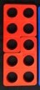
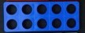
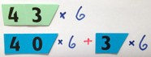
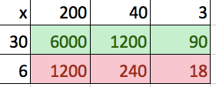
Multiplication
Written Methods |  | Calculate mathematical statements for multiplication and division within the multiplication tables and write them using the multiplication (×), division (÷) and equals (=) signs | 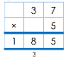  Write and calculate mathematical statements for ÷ using the x tables they know. . Multiply two-digit number by a one-digit number using formal written layout. | Multiply two-­‐digit and  three-­‐digit numbers by 243  a one-­‐digit number x 6  using formal written 1458  layout 21 | Multiply numbers up to 4 243  digits by a one-­‐ or two-­‐digit x 36 number using a formal 1458  written method, including 7290 long multiplication for two-­‐ 8748 digit numbers 1 | Multiply multi-­‐digit numbers up to 4 digits by a two-­‐digit whole number using the formal written method of long multiplication  5172  x 38 41376  + 155160  196536  1  2  1 5 1  5172  x 38 41376  + 155160  196536  1  5172  x 38  41376  1 5 1  + 155160  2  196536  1  Multiplying and dividing by 10, 100 and 1000.  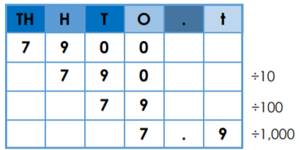
Developing conceptual understanding | Equal groupings- 2 frogs on each lily pad.  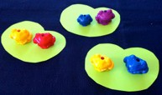  Arrays  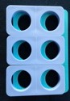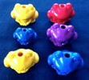  Adding equal groups- counting up  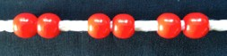  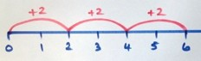  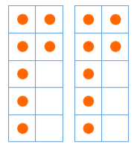  Doubling amounts | Commutative – 5 x 3 = 3 x 5  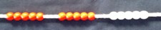  Repeated addition  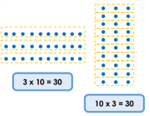  Build tables on counting stick  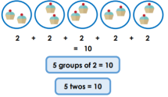  Arrays | If I know 10 x 8 = 80 then …  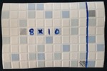  So 13 x 4 = 10 x 4 + 3 x 4  Build tables on counting stick  Doubling known facts.  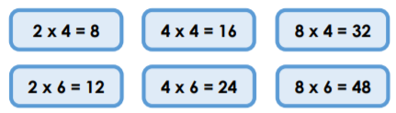 | 43 x 6 by partitioning  X 40 3  6 240 18  40 x 6 = 240  3 x 6 = 18  43 x 6 = 258  If I know 4 x 6 = 24  then 40 x 6 is ten times bigger. Build tables on counting stick.  Related facts- inverse  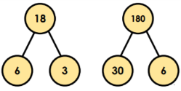  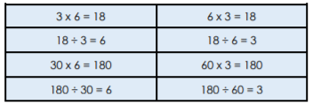 | Grid method linked to formal written method  = 7290  = 1458 +  8748  If I know 4 x 6 then 0.4 x 6 is ten times smaller  0.4 x 0.6 is ten times smaller again.  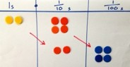  Multiply by 10, 100 and 1000 using a place value grid if needed.  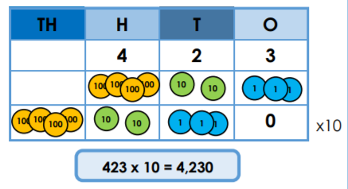
With jottings  … or in your head …. | Solve one-­‐step problems involving multiplication and division, by calculating the answer using concrete objects, pictorial representations and arrays with the support of the teacher | Show that multiplication of two numbers can be done in any order (commutative) and division of one number by another cannot  Solve problems involving multiplication and division, using materials, arrays, repeated addition, mental methods, and multiplication and division facts, including problems in contexts | Write and calculate mathematical statements for multiplication and division using the multiplication tables that they know, including for two-­‐digit numbers times one-­‐digit numbers, using mental methods | Use place value, known and derived facts to multiply and divide mentally, including: multiplying by 0 and 1; dividing by 1; multiplying together three numbers  Recognise and use factor pairs and commutativity in mental calculations | Multiply and divide numbers mentally drawing upon known facts  Multiply and divide whole numbers and those involving decimals by 10, 100 and 1000  Identify multiples and factors, including finding all factor pairs of a number, and common factors of two numbers establish whether a number up to 100 is prime | Perform mental calculations, including with mixed operations and large numbers
Just know it! | Count in multiples of twos, fives and tens | Recall and use x and ÷ facts for the 2, 5 and 10 x tables, including recognising odd and even numbers. | Recall and use x and ÷ facts for the 3, 4 and 8 times tables. | Recall x and ÷ facts for x tables up to 12 x 12. | Recall prime numbers up to 19  know and use the vocabulary of prime numbers, prime factors and composite (non-­‐prime) numbers  Recognise and use square numbers and cube numbers, and the notation for squared (²) and cubed (³)
Year | 1 | 2 | 3 | 4 | 5 | 6
Foundations | Count in 2s | 2 x table | Review 2x, 5x and 10x | 4x, 8x tables 10 times bigger | 4x, 8x tables  100, 1000 times bigger | Multiplication facts up to 12 x 12
 | Count in 10s | 10 x table | 4x table | 3x, 6x and 12x tables | 3x, 6x and 12x tables 10, 100, 1000 times smaller | Partition to multiply mentally
 | Doubles up to 10 | Doubles up to 20 and multiples of 5 | Double two digit numbers | Double larger numbers and decimals | Double larger numbers and decimals | Double larger numbers and decimals
 | Count in 5s | 5 x table | 8 x table | 3x, 9x tables | 3x, 9x tables | Multiplication facts up to 12 x 12
 | Double multiples of 10 | Count in 3s | 3 x table | 11x, 7 x tables | 11x , 7 x tables Partition to multiply mentally | Partition to multiply mentally
 | Count in 2s, 5s and 10s | 2 x, 5 x and 10 x tables | 6 x table or review others | 6x, 12 x tables | 6x, 12 x tables | Double larger numbers and decimals

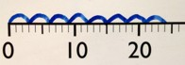
Division

 |  | Calculate mathematical | Write and calculate mathematical | 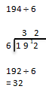  Divide two-digit and three-digit numbers by a one-digit number using a formal written layout. | Divide numbers up to |  | Divide numbers up to 4-­‐digits by a two-­‐digit whole number using the formal written method of short division where appropriate for the context  Using 1 13  564 ÷ 13 known 2 26  multiplication 5 130  facts 10 260  4 3 r 5 20 520  13 5 6 44  !  564 ÷ 13 = 43 r 5 = 43 = 43.38...  !"  4 3 . 3 8 …  13 5 6 44 .50110  Divide numbers up to 4 digits by a two-­‐digit whole number using the formal written method of long division, and interpret remainders as whole number remainders, fractions, or by rounding, as appropriate for the context  4 3 r 5  13 5 6 4  5 2 0 (13 x 40)  4 4  -­‐ 3 9 (13 x 3)  5  564 ÷ 13 = 43 r 5  = 43 5/13  = 43.38
 |  | statements for multiplication and | statements for ÷ using the x |  | 4 digits by a one-­‐digit | 194 ÷ 6
 |  | division within the multiplication | tables they know. Divide two-digit numbers byt |  | number using the
Written Methods |  | tables and write them using the multiplication (×), division (÷) and equals (=) signs | by a one-digit number using a formal written layout. |  | formal written method of short division and interpret | 3 2  6 1 9 12
 |  |  | 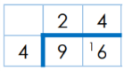 |  | remainders | 192 ÷ 6
 |  |  |  |  | appropriately for the | = 32
 |  |  |  |  | context
Developing conceptual understanding | 6 ÷2 = 3 by sharing into 2 groups and by grabbing groups of 2  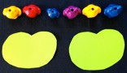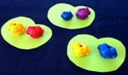  Arrays  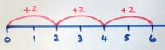  How many 2s?  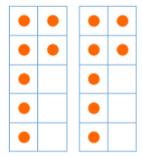  Sharing equally  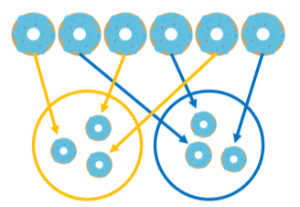  Halving an amount equally | 15 ÷ 3 = 5 in each group (sharing)  Link to fractions 15 ÷ 3 = 5 groups of 3 (grouping)  10 ÷2 = 5  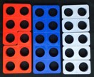  Use language of division linked to tables . How many 2s?  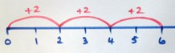  Related division facts | Grouping using partitioning 43 ÷ 3 If I know 10 x 3 …  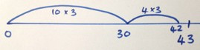  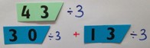  Use language of division linked to tables  How many 3s?  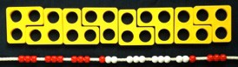 | Grouping using partitioning  196 ÷ 6 If I know 3 x 6 … then 30 x 6…  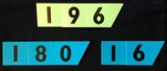  ‘Chunking up’ on a number line 196 ÷ 6 = 32 r 4  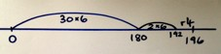  Use language of division linked to tables. Counting stick  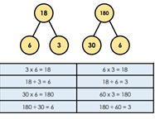  Related facts- inverse | Division using place value counters to support method.  192 ÷ 6 using place value counters to support written method.  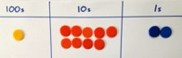  Exchange the 1 hundred for 10 tens. There are now 19 tens in the 10s column.  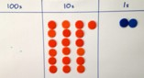  Share into groups of 6. Any remainders put in the 1s column.  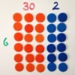  Share the ones into equal groups of 6. There are 32 groups of 6.  Divide by 10, 100 and 1000 using place value grid if needed.
With jottings  … or in your head …. | Solve one-­‐step problems involving multiplication and division, by calculating the answer using concrete objects, pictorial representations and arrays with the support of the teacher | Show that multiplication of two numbers can be done in any order (commutative) and division of one number by another cannot  Solve problems involving multiplication and division, using materials, arrays, repeated addition, mental methods, and multiplication and division facts, including problems in contexts | Write and calculate mathematical statements for multiplication and division using the multiplication tables that they know, including for two-­‐digit numbers times one-­‐digit numbers, using mental methods | Use place value, known and derived facts to multiply and divide mentally, including: multiplying by 0 and 1; dividing by 1; multiplying together three numbers Recognise and use factor pairs and commutativity in mental calculations | Multiply and divide numbers mentally drawing upon known facts  Multiply and divide whole numbers and those involving decimals by 10, 100 and 1000 |  | Perform mental calculations, including with mixed operations and large numbers
Just know it! | Count in multiples of twos, fives and tens | Recall and use x and ÷ facts for the 2, 5 and 10 x tables, including recognising odd and even numbers. | Recall and use x and ÷ facts for the 3, 4 and 8 times tables. | Recall x and ÷ facts for x tables up to 12 x 12. | Recall prime numbers up to 19  know and use the vocabulary of prime numbers, prime factors and composite (non-­‐prime) numbers
Year | 1 | 2 | 3 | 4 | 5 |  | 6
Foundations | Count back in 2s | Division facts (2 x table) | Review division facts (2x, 5x, 10x table) | Division facts (4x, 8x tables) 10 times smaller | Division facts (4x, 8x tables) 100, 1000 times smaller |  | Division facts (up to 12 x 12)
 | Count back in 10s | Division facts (10 x table) | Division facts (4 x table) | Division facts (3x, 6 x, 12x tables) | Division facts (3x, 6 x, 12x tables) Partition to divide mentally |  | Partition to divide mentally
 | Halves up to 10 | Halves up to 20 | Halve two digit numbers | Halve larger numbers and decimals | Halve larger numbers and decimals |  | Halve larger numbers and decimals
 | Count back in 5s | Division facts (5 x table) | Division facts (8 x table) | Division facts (3x, 9x tables) | Division facts (3x, 9x tables) 100, 1000 times smaller |  | Division facts (up to 12 x 12)
 | Halve multiples of 10 | Count back in 3s | Division facts (3 x table) | Division facts (11x, 7x tables) | Review division facts (11x, 7x tables) Partition decimals to divide mentally |  | Partition to divide mentally
 | How many 2s? 5s? 10s? | Review division facts (2x, 5x, 10x table) | Division facts (6 x table) or review others | Division facts (6x, 12x tables) | Review division facts (6x, 12x tables) Halve larger numbers and decimals |  | Halve larger numbers and decimals

