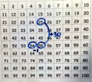
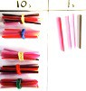
Addition
Written Methods | Read, write and interpret mathematical statements involving addition (+), subtraction (–) and equals (=) signs | Add and subtract two two-digit numbers using concrete objects, pictorial representations progressing to formal written methods  4 6  + 2 7  7 3  1 | Add and subtract numbers with up to three digits, using formal written methods of columnar addition and subtraction  4 2 3  + 8 8  5 1 1  1 1 | Add and subtract numbers with up to 4 digits using the formal written methods of columnar addition where appropriate  2 4 5 8  + 5 9 6  3 0 5 4  1 1 1  Add 1s, 10s, 100s and 1000s. Use understanding of place value to add mentally.  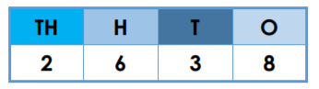  Estimation- we can estimate to see if an answer is correct.  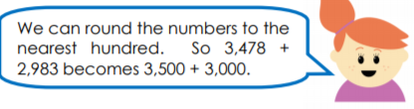  Use base 10 to show column addition.  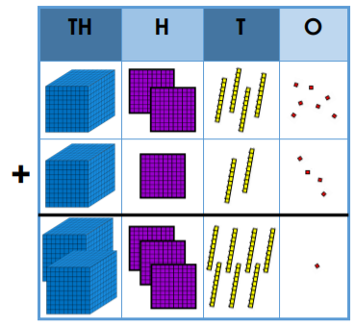 | Add and subtract whole numbers with more than 4 digits (including decimals), using formal written methods (columnar addition and subtraction)  Estimation- we can estimate to see if an answer is correct.  Use inverse to check an answer.  67 + 33 = 100  100- 67 = 33  2 3 4 5 4  + 5 9 6  2 4 0 5 0  1 1 1  2 3 4. 5 8  + 7 5. 9 6  3 1 0. 5 4  1 1 1 1 | Solve addition and subtraction multi-step problems in contexts, deciding which operations and methods to use and why  Estimation- we can estimate to see if an answer is correct.  Use inverse to check an answer.  234 + 33 = 267  267 – 234 = 33  2 3 4 5 4  + 5 9 6  2 4 0 5 0  1 1 1  2 3 4. 5 8  + 7 5. 9 6  3 1 0. 5 4  1 1 1 1
Developing conceptual understanding | Number bonds  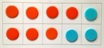  (Ten frame) Numicon Use bonds of 10 to calculate bonds of 20  Count all  Count on from a given number  8  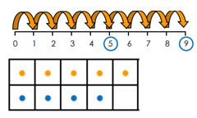  Count on, on number track, in 1s  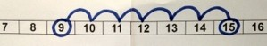 | Number track / Number line – jumps of 1 then efficient jumps using number bonds 18 + 5 = 23  46 + 27 = 73 Count in tens then bridge.  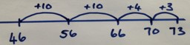  25 + 29 by + 30 then -1 (Round and adjust)  Partition and recombine  46 + 27 = 60 + 13 = 73  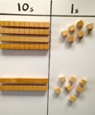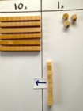  24 +10  +10  +10 = 54 | Number line: 264 + 158 efficient jumps  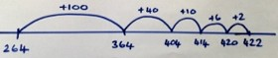  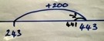  40 + 80 = 120 using 4 + 8 = 12  So 400 + 800 = 1200  243 + 19 by +200 then -2 (Round and adjust)  Pairs that make 100 = 23 + 77  Place value counters, 100s, 10s, 1s 264 + 158  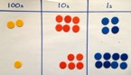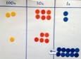  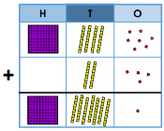  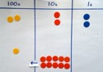  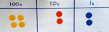  42Base 10 to show column addition.
With jottings  … or in your head | Solve one-step problems that involve addition and subtraction, using concrete objects and pictorial representations, and missing number problems such as 7 = D – 9 | Add and subtract numbers using concrete objects, pictorial representations, and mentally, including:  - a two-digit number and ones  - a two-digit number and tens  - two two-digit numbers  - adding three one-digit numbers | Add and subtract numbers mentally, including:  - a three-digit number and ones  - a three-digit number and tens  - a three-digit number and hundreds | Solve addition and subtraction two-step problems in contexts, deciding which operations and methods to use and why | Add and subtract numbers mentally with increasingly large numbers | Perform mental calculations, including with mixed operations and large numbers
Just know it! | Represent & use number bonds and related subtraction facts within 20 Add and subtract one-digit and two- digit numbers to 20, including zero | Recall and use addition and subtraction facts to 20 fluently, and derive and use related facts up to 100
Year | 1 | 2 | 3 | 4 | 5 | 6
Foundations | 1 more | 10 more  Number bonds: 20, 12, 13 | Add multiples of 10, 100 | Add multiples of 10s , 100s, 1000s | Add multiples of 10s , 100s, 1000s, tenths, | Add multiples of 10s , 100s, 1000s, tenths, hundredths
 | Number bonds: 5, 6 | Number bonds: 14,15  Add 1 digit to 2 digit by bridging. | Add single digit bridging through boundaries | Fluency of 2 digit + 2 digit | Fluency of 2 digit + 2 digit including with decimals | Fluency of 2 digit + 2 digit including with decimals
 | Number bonds: 7, 8 | Partition to add, add tens then ones | Partition numbers to add | Decimal pairs to 10 and 1 (1 decimal place) | Use number facts, bridging and place value | Use number facts, bridging and place value
 | Add 10.  Number bonds: 9, 10 | Add 10 and multiples. Number bonds: 16 and 17 | Use near doubles to add | Use near doubles to add | Partition and recombine | Partition and recombine
 | Ten plus ones. Doubles up to 10 | Doubles up to 20 and multiples of 5 Add near multiples of 10. | Add near multiples of 10 and 100 by rounding and adjusting | Adjust both numbers before adding Add near multiples
 | Use number bonds of 10 to derive bonds of 11 | Number bonds: 18, 19 Partition and recombine | Partition and recombine | Partition and recombine

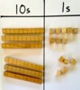
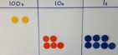
Subtraction
Written Methods | Read, write and interpret mathematical statements involving addition (+), subtraction (–) and equals (=) signs | Add and subtract two two-digit numbers using concrete objects, pictorial representations progressing to formal written methods 6 1  7 3  - 4 6  2 7 | Add and subtract numbers with up to three digits, using formal written methods of columnar addition and subtraction 2 3 1  3 4 4  - 1 8 7  1 5 7 | Add and subtract numbers with up to 4 digits using the formal written methods of columnar addition where appropriate  1  2 3 1  2 3 4 4  - 1 8 7  2 1 5 7  Subtract 1s, 10s, 100s and 1000s. Use understanding of place value to subtract mentally.  Estimation- we can estimate to see if an answer is correct.  Use base 10 to show formal subtraction.  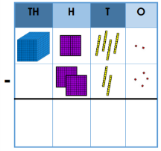 | Add and subtract whole numbers with more than 4 digits, including using formal written methods (columnar addition and subtraction)  1  2 3 1  5 2 3 4 4  - 1 1 8 7  5 1 1 5 7  Estimation- we can estimate to see if an answer is correct.  Use inverse to check an answer.  67 + 33 = 100  100- 67 = 33 | Solve addition and subtraction multi-step problems in contexts, deciding which operations and methods to use and why  Estimation- we can estimate to see if an answer is correct.  Use inverse to check an answer.  234 + 33 = 267  267 – 234 = 33  2 3 4 5 4  + 5 9 6  2 4 0 5 0  1 1 1  2 3 4. 5 8  + 7 5. 9 6  3 1 0. 5 4  1 1 1 1
Developing conceptual understanding | Number bonds  (Ten frame) Difference between  7 and 10  6 less than 10 is 4  Count out, then count how many are left.  7 – 4 = 3  Count back on a number track, then number line.  15 – 6 = 9  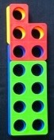  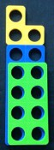  Difference between 13 and 8  13 – 8 = _  8 + _ = 13  Fact families  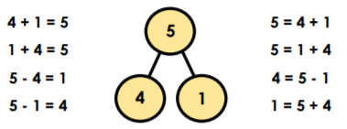 | Number track / Number line – jumps of 1 then efficient jumps using number bonds 23 – 5 = 18  Using a number line, 73 – 46 = 26  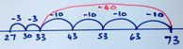  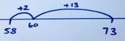  Difference between 73 – 58 by counting up, 58 + _ = 73  Subtraction facts to 100.  Taking away and exchanging,  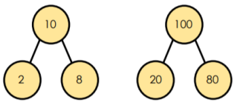  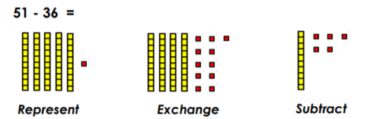 | Place value counters and base 10 to show formal method.  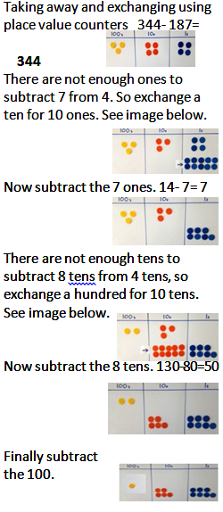  Difference between 73 – 58 by counting up, 58 + _ = 73
With jottings  … or in your head | Solve one-step problems that involve addition and subtraction, using concrete objects and pictorial representations, and missing number problems such as 7 = D – 9 | Add and subtract numbers using concrete objects, pictorial representations, and mentally, including:  - a two-digit number and ones  - a two-digit number and tens  - two two-digit numbers  - adding three one-digit numbers | Add and subtract numbers mentally, including:  - a three-digit number and ones  - a three-digit number and tens  - a three-digit number and hundreds | Solve addition and subtraction two-step problems in contexts, deciding which operations and methods to use and why | Add and subtract numbers mentally with increasingly large numbers | Perform mental calculations, including with mixed operations and large numbers
Just know it! | Represent and use number bonds and related subtraction facts within 20  Add and subtract one-digit and two- digit numbers to 20, including zero | Recall and use addition and subtraction facts to 20 fluently, and derive and use related facts up to 100
Year | 1 | 2 | 3 | 4 | 5 | 6
Foundations | 1 less | 10 less  Number bonds, subtraction: 20, 12, 13 | Subtract multiples of 10 and 100 | Subtract multiples of 10s , 100s, 1000s | Subtract multiples of 10s , 100s, 1000s, tenths, | Subtract multiples of 10s , 100s, 1000s, tenths, hundredths
 | Number bonds, subtraction: 5, 6 | Number bonds, subtraction: 14, 15 Subtract 1 digit from 2 digit by bridging | Subtract single digit by bridging through boundaries | Fluency of 2 digit subtract 2 digit | Fluency of 2 digit - 2 digit including with decimals | Fluency of 2 digit - 2 digit including with decimals
 | Count back  Number bonds, subtraction: 7, 8 | Partition second number, count back in 10s then 1s | Partition second number to subtract | Partition second number to subtract  Decimal subtraction from 10 or 1 | Partition second number to subtract | Partition second number to subtract
 | Subtract 10.  Number bonds, subtraction: 9, 10 | Subtract 10 and multiples of 10  Number bonds, subtraction: 16, 17 | Difference between | Difference between | Use number facts bridging and place value | Use number facts bridging and place value
 | Teens subtract 10. | Subtract near multiples of 10 | Subtract near multiples of 10 and 100 by rounding and adjusting | Subtract near multiples by rounding and adjusting | Difference between | Difference between
 | Difference between | Difference between Number bonds, subtraction: 18, 19 | Difference between | Difference between

